# How to determine operating system version in .NET Core

# Introduction

This sample demonstrates how to determine operating system version in .NET Core.

**Sample prerequisites**

* Visual Studio 2017 or above [[Visual Studio Home Page](https://www.visualstudio.com/)]

## Building the sample

* Open the sample solution “CSNETCoreOSVersion.sln” using Visual Studio
* Right click the project “CSNETCoreOSVersion” and select Restore Packages
* Press **F6** Key or select **Build -> Build Solution** from the menu to build the sample.

## Running the sample

* Open the sample solution using Visual Studio, then press F5 Key or select Debug -> Start Debugging from the menu.

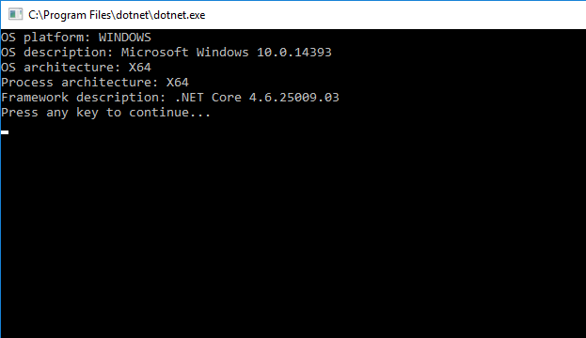

**Using the code**

Program.cs :

public static OSPlatform GetOSPlatform()

{

OSPlatform osPlatform = OSPlatform.Create("Other Platform");

// Check if it's windows

bool isWindows = RuntimeInformation.IsOSPlatform(OSPlatform.Windows);

osPlatform = isWindows ? OSPlatform.Windows : osPlatform;

// Check if it's osx

bool isOSX = RuntimeInformation.IsOSPlatform(OSPlatform.OSX);

osPlatform = isOSX ? OSPlatform.OSX : osPlatform;

// Check if it's Linux

bool isLinux = RuntimeInformation.IsOSPlatform(OSPlatform.Linux);

osPlatform = isLinux ? OSPlatform.Linux : osPlatform;

return osPlatform;

}

## More information

[RuntimeInformation class](https://docs.microsoft.com/de-de/dotnet/core/api/system.runtime.interopservices.runtimeinformation)